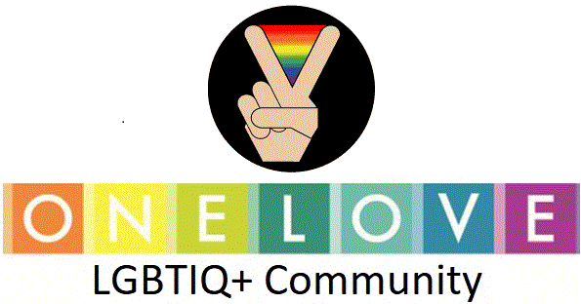 | Volunteer Application Form
 | Date last updated: 18 May 2018

This form should be used by anyone wishing to volunteer @ One Love LGBTIQ+ Community . One Love LGBTIQ+ Community works with our volunteers toward a fair and equal society where all LGBT people can achieve their full potential. If you are having difficulties completing this form for any reason, please contact the Volunteer Programme Co-ordinator on 012 403 0453. All completed forms must be submitted to the Volunteer Programme Co-ordinator. Via Email onelovelgbtiq@gmail.com

PERSONAL DETAILS

Full Name

Address
Postcode

Telephone: | Mobile:
Email address: | Date of Birth:

Preferred method of contact (please tick all that apply, but please note that when we contact you we will usually only use one, not all, preferred method)

Post |  | Email |  | Telephone |  | Mobile |  | Text
If we need to leave you an answerphone message, is this OK? |  |  |  |  |  | Yes |  | No

Next of Kin/Emergency Contact:
(for use in emergency only)

Next of Kin Contact Telephone: (include area code) | Next of Kin Email:

What pronoun would you like us to use for you? There is no obligation to answer, but it will help us address you as you wish to be addressed.

She/Her |  | He/His |  | They/Their |  | Other:

Are there any reasonable adjustments you may need while volunteering with us? Please note that this will in no way have a negative impact on your application and is for us to make sure your volunteering experience is as positive and inclusive as possible. The information you give will be kept confidential. Please describe any adjustments you may need below.

APPLICATION QUESTIONS

If you need more space to write your answers, please continue over the page and clearly mark which question your answer relates to.

What specific role, if any, will you be applying for?*

*Please note if you are not applying for a specific role your application will take longer to process

What is your most recent education/qualification?

What are your hobbies and interests?

What (if any) is your previous volunteering experience?

What skills and experience do you feel you can bring to LGBT Foundation?

What times would be best for you to volunteer?

Anytime |  | Weekday Daytime |  | Weekday Evenings |  | Weekends

Where did you hear about volunteering with LGBT Foundation?

Is there anything in your background to tell us about that you think may affect your suitability to volunteer in certain areas @ One Love LGBTIQ+ Community? (this information is kept completely confidential and a separate meeting will be booked with the Volunteer Manager to discuss further)

Yes |  | No

Would you be interested in setting up a direct debit to make a small donation to One Love LGBTIQ+ Community? There is no obligation to as a volunteer, but if you are interested we will contact you separately to set one up!

Yes |  | No

REFERENCES

PLEASE PROVIDE TWO REFERENCES. If you have worked in the past five years, at least one of your two references should be obtained from your last employer. If not, please give the names of people who know you well (ideally at least two years). If you are able to provide an email address for your references, we can check them more quickly.

REFEREE 1

Name

Address
Postcode

Telephone Number:
Email Address:
In what capacity do they know you?

REFEREE 2

Name

Address
Postcode

Telephone Number:
Email Address:
In what capacity do they know you?
DECLARATION

I understand that any offer of volunteering with One Love LGBTIQ+ Community is subject to satisfactory references, and binding in honour only.

I agree that the One Love LGBTIQ+ Community may hold and use personal information about me for volunteering reasons and to keep in touch with me. This information, including that contained in this form can be stored both manually or computer files. It will be held securely and only accessed by authorised personnel.

Signature | Date

Print Name

